

East West University

Department of Computer Science and Engineering
Semester : Spring 2021
Course Title: Electrical Circuits
Course Code: CSE209
Section: 03

Experiment Number: 07
Experiment Title: DC Circuit Analysis in PSpice using Source and Resistance Sweep

Student Name: Md. Rakibur Rahman
ID: 2019-3-60-113

Date of Performance: 05.05.2021
Date of Submission: 09.05.2021

Objectives:
- To analyze DC circuit in PSpice by sweeping source and resistance.
- To verify maximum power transfer theorem.

Circuit Diagram:
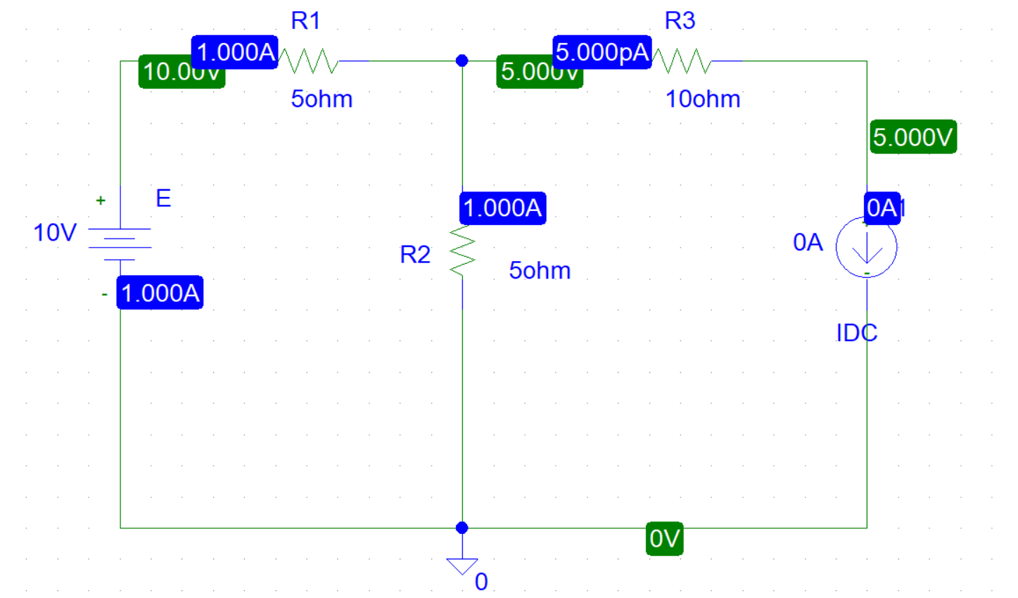
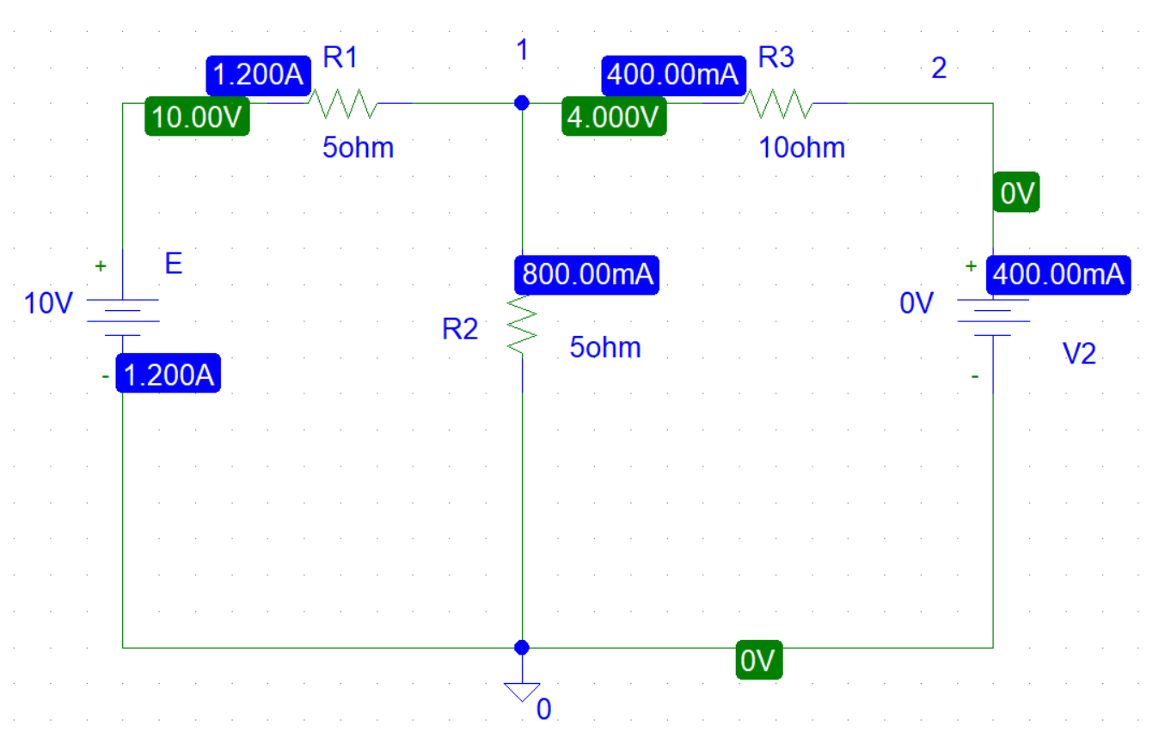
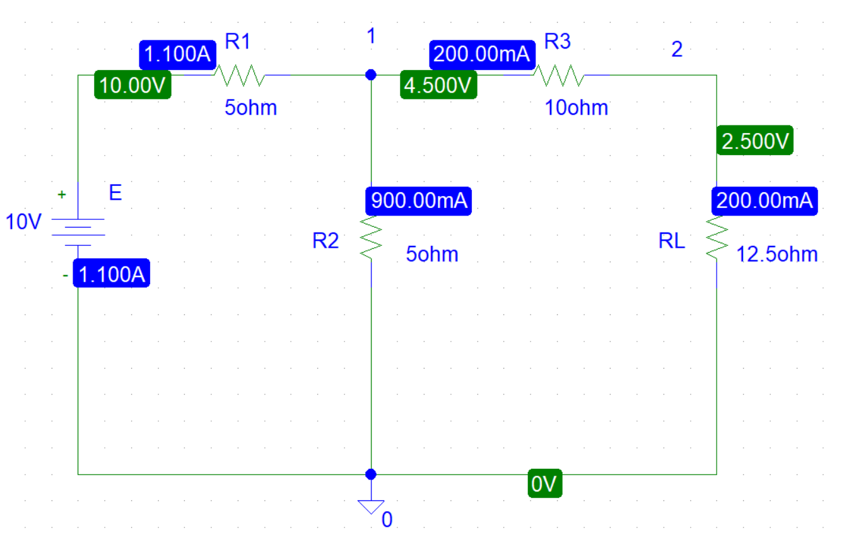
Answers to the post lab report questions:

- From step 4,
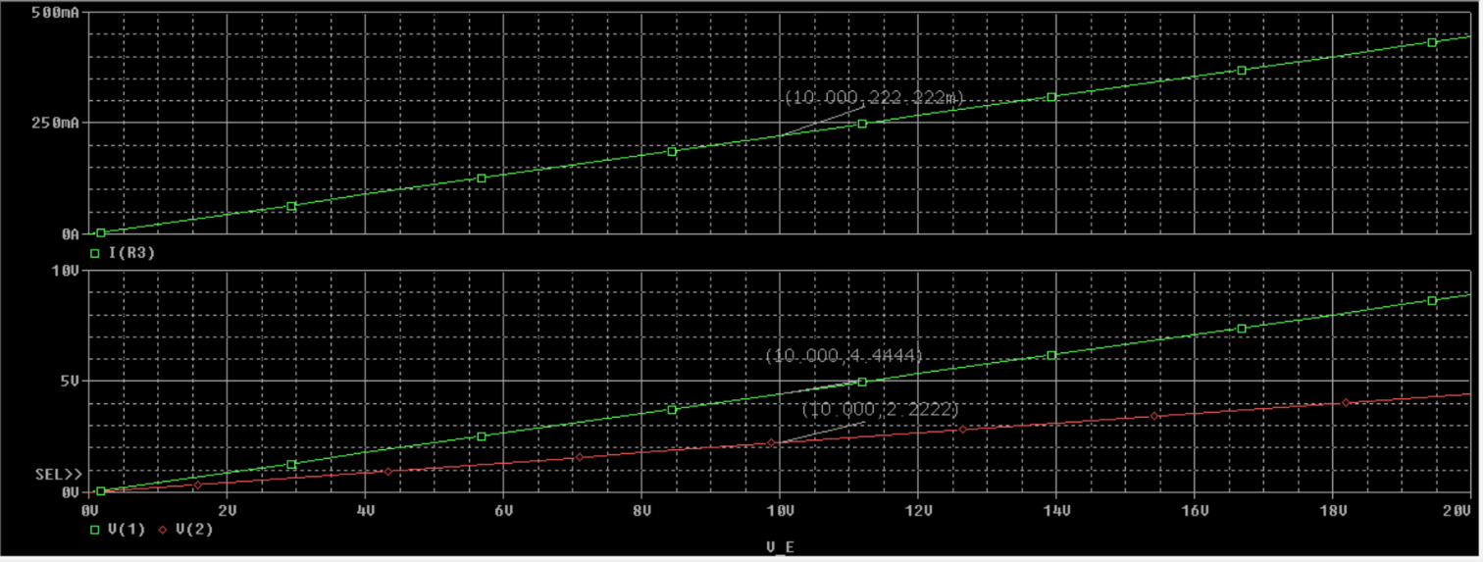

From step 5(d),
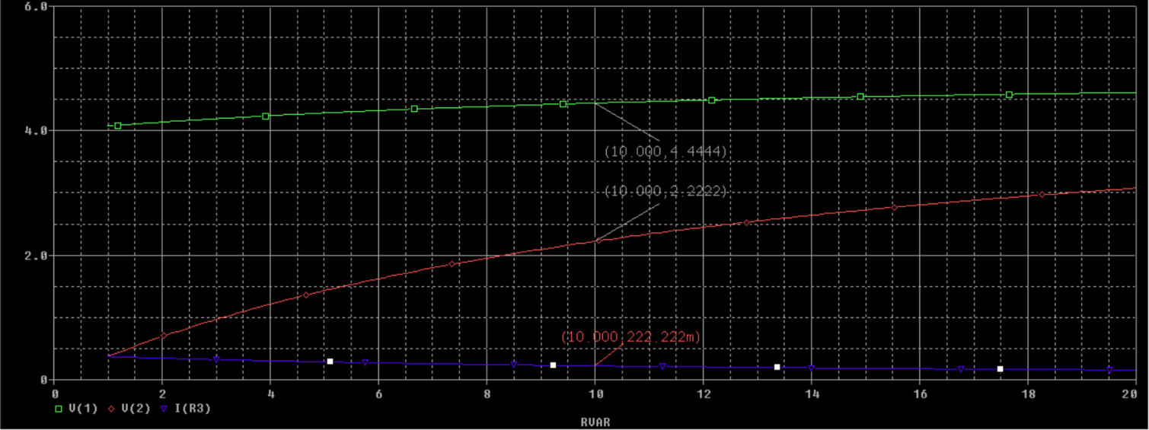

Comparing the values of V(1), V(2) and I(R3) obtained in steps 4 and 5(d),
Values | Step 4 | Step 5(d)
V₁ | 4.4444V | 4.4444V
V₂ | 2.2222V | 2.2222V
I(R₃) | 222.222mA | 222.222mA

Here, the values of step 4 & step 5(d) are same.

- From step 2,


Here , I_{SC} =400mA =0.4A
V_{th} = 5V ^{[from step 1]}
R_{th} = $\frac{Vth}{Isc}$= $\frac{5}{0.4}$ Ω = 12.5 Ω
Here , R_{th} =R_{L}=12.5

From step 5(e),

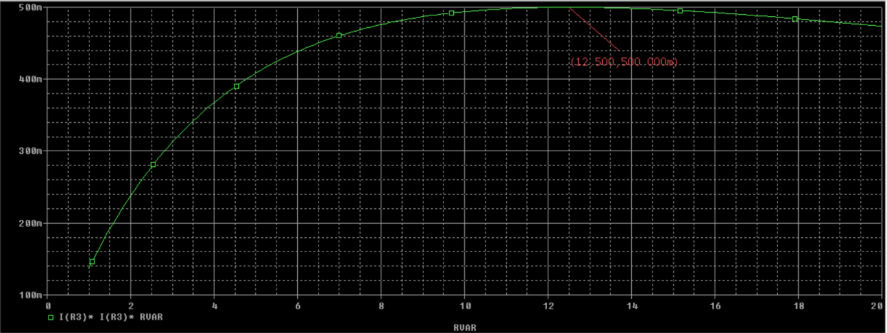

Comparing the load resistance RL for maximum power transfer obtained in steps 2 and 5(e),

Step 2 | Step 5(e)
12.5 Ω | 12.5 Ω

R_{L} for maximum power transfer obtained in step 2 & 5(e) are same.

3.

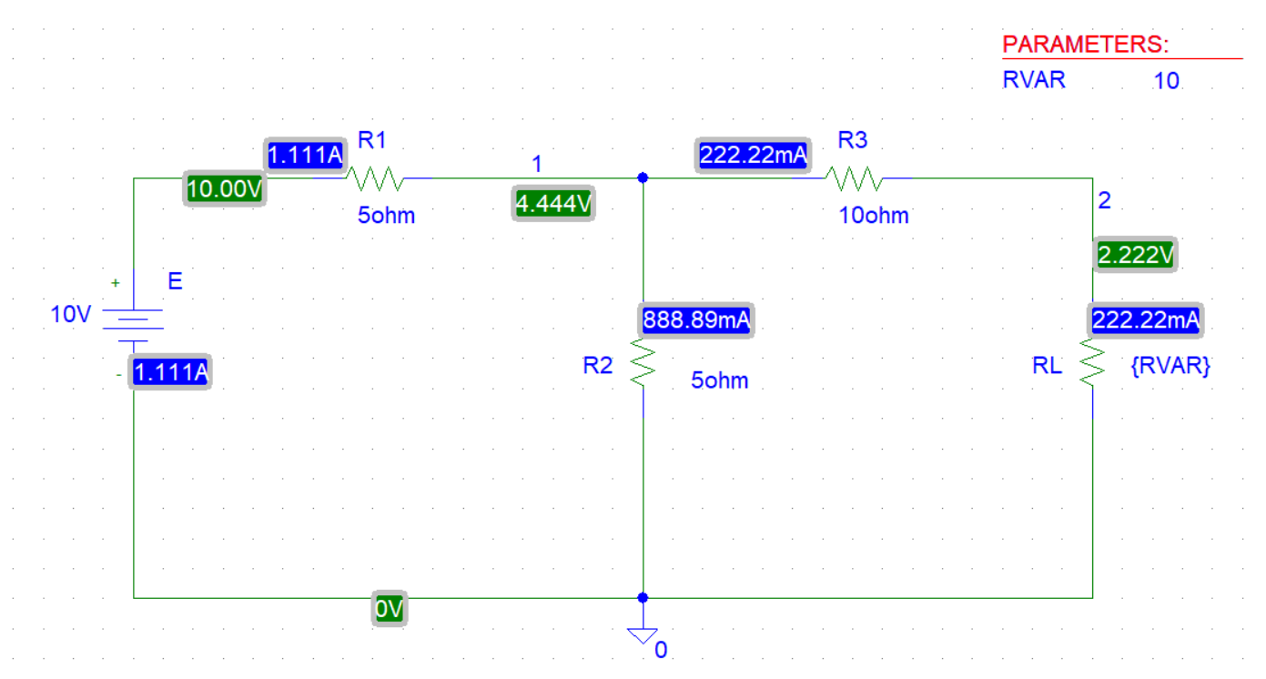
Applying KCL at node 1,
$\frac{V1-10}{5}$ + $\frac{V1-V2}{10}$ + $\frac{V1}{5}$ = 0
0.5V₁ – 0.1V₂ =2…..(1)
Applying KCL at node 2,
$\frac{V2-V1}{10}$ + $\frac{V2}{10}$ = 0
-0.1V₁ +0.2V₂ =0……(2)
Solving equation 1 & 2,
V₁ =4.4444 V
V₂ = 2.2222V
I(R₃) =$\frac{V1-V2}{R3}$
=$\frac{4.4444-2.2222}{10}$
=222.22mA

Comparing the theoretical solutions with the solutions obtained from PSpice,
Values | PSpice | Calculated
R_{L} | 12.5 Ω | 12.5 Ω
V₁ | 4.444V | 4.4444V
V₂ | 2.222V | 2.2222V
I(R₃) | 222.22mA | 222.22mA

The calculated values & the simulated values are the same. Thus, there is no discrepancy.

Conclusion: In this experiment , we learnt about analyzing DC circuit in PSpice by sweeping source and resistance. And verifying maximum power transfer theorem. We found that, there is no discrepancy in the calculated & simulated values.

